CLASSROOM ACTIVITES

- ACTIVITY EXAMPLES
- Students can write a letter to God, asking for His forgiveness and grace
- Students can pairs in groups to research and present visually a specific symbol or rite or component of the Sacrament of Penance which will be hung in a corner of the classroom
- After examining the forgiveness song by Alicia Keys or Matthew West (or comparing the two songs), students to note attributes of forgiveness evident in the sons. They are to then work in small groups to create their own forgiveness song.
- Have students make invitation cards for their families, to invite them to their Sacrament of Reconciliation. They are to write the information of the evening as well as one fact they have learnt about the Sacrament
- Word Puzzles and Fill-in-the-blanks
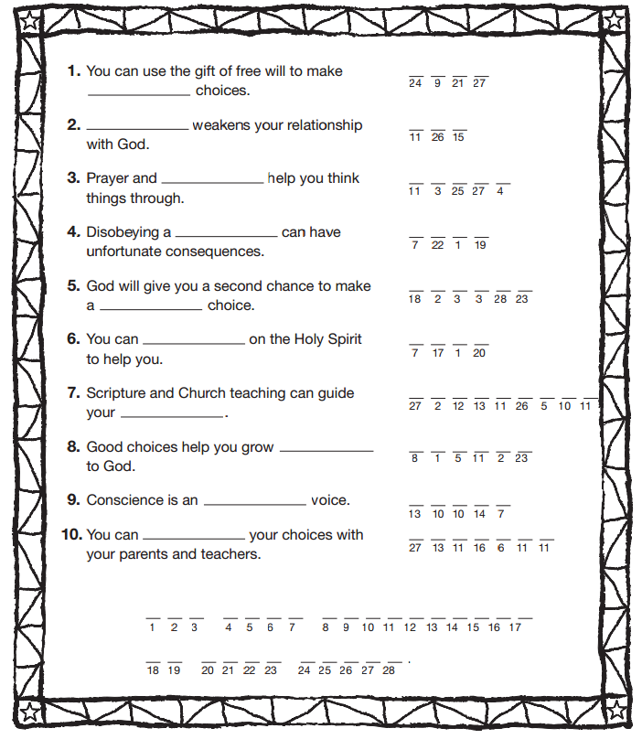
My ___________, I am ________________ for my sins with all my

_____________. In __________________ to do ______________ and

_________________ to do ________________, I have ___________________

against you whom I should ______________ above all things. I firmly

_________________, with your ________________, to do __________________,

to sin no more, and to _______________ whatever _______________ me to sin.

Our Savior _______________ Christ suffered and _____________ for us. In His

name, my God, have _________________. ____________.

Word bank:
Help Failing Jesus Mercy God Sorry Sinned Penance Amen Avoid Died Leads Good Choosing Love Heart Intend Wrong

- Building upon their conscious and judgment of their actions through scenarios
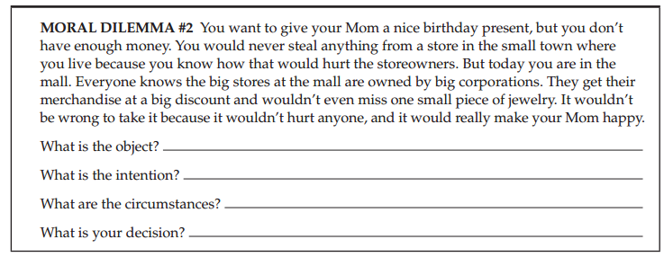
- Mediation
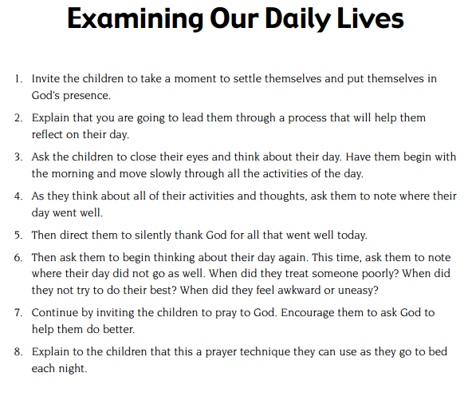
- Together in Jesus: First Reconciliation and First Eucharist Preparation Programs by Pflaum
- Students will be divided into groups and given a life scenario. They are to present this to the class, in which the class will try and guess which element of Penance the scenario is indicating
- Adaptive Reconciliation Kit to cater for students with additional needs
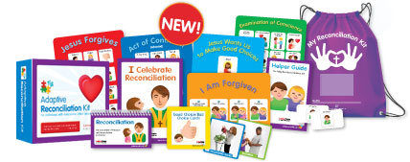
- Games:
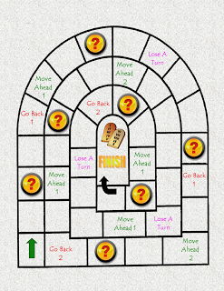 http://catholicblogger1.blogspot.com.au/2009/05/reconciliation-file-folder-game.html

- Have students examine artworks and note how the artist has used various artistic technique to convey meaning
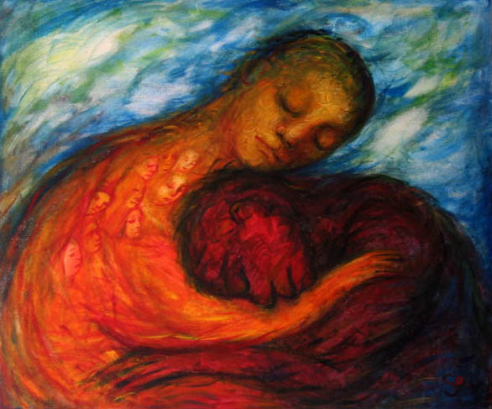 Forgiveness by Sofiya inger
- Read and examine Scripture readings such as the Parable of the Prodigal Son http://www.ebibleteacher.com/sites/default/files/flipcharts/1/pdf/ProdigalSonStory_0.pdf
- Review the Sacraments of Reconciliation PowerPoint by Tess Stangas http://www.authorstream.com/Presentation/tassvpa-1015686-sacrement-of-reconciliation/
- Read and examine 10 Steps of the Sacrament of Reconciliation for children
http://www.ctkri.org/ReligiousFormation/Docs/Reconciliation
Ceremony.pdf
- Songs; Create a class song
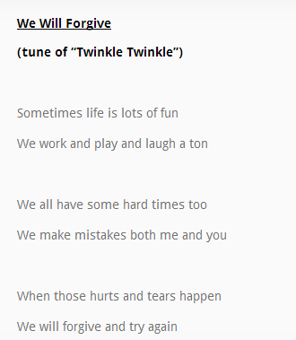

- Godly Play of the Parable of the Lost Sheep and Parable of Prodigal Son
- Have students create their own Penance book in which they write key terms they have learnt, the three rites, key signs and symbols and understand individual reflection such as:
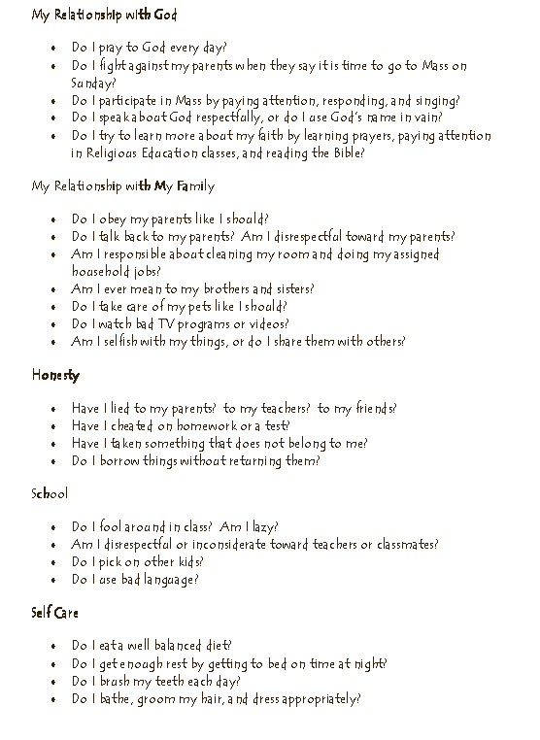
- Prayers

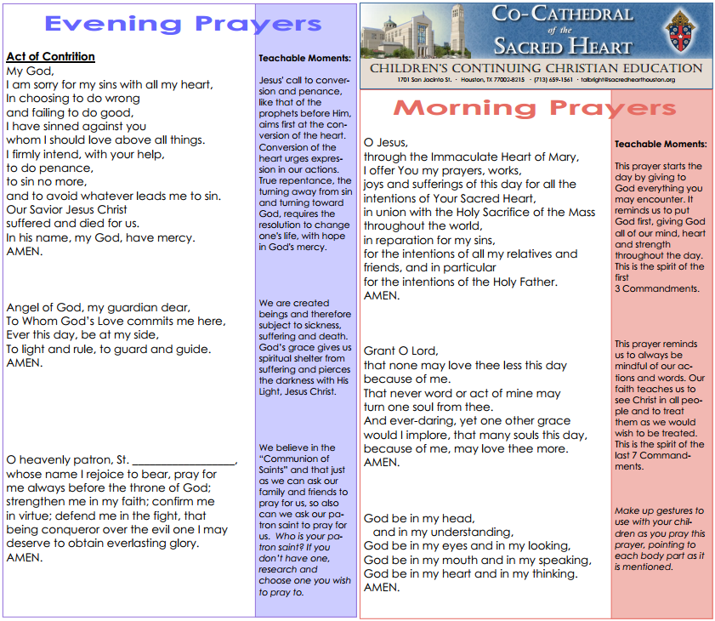

- TEACHERS RESOURCES TO GAIN IDEAS OF ENGAGING ACTIVITIES

Enhancing the teaching of the Sacrament of Reconciliation by the Catholic Education Office of Western Australia
http://www.ceo.wa.edu.au/home/harris.joanne/Enhancing_the_Teaching_of_the_Sacrament_of_Reconciliation/Penance_booklet.pdf

5.7 We Celebrate the Sacraments (Part 1) by the Archdiocese of Sydney Religious Education Curriculum
http://www.ceosyd.catholic.edu.au/Parents/Religion/RE/recurr/tres-curr-5.7.doc

First Reconciliation by Pinterest
http://www.pinterest.com/mlln/first-reconciliation/

Forgiveness by Focus on Family Association
http://www.kidsofintegrity.com/sites/default/files/Forgiveness.pdf

Forgiveness Online
http://www.enablemetogrow.com/forgiveness/

God’s Gift: Reconcilation and Eucharist by Loyola Press

Home Resources for Sacramental Preparation of Children; Reconcilation (Confession or Penance)
http://www.sacredhearthouston.org/index.cfm?load=page&page=358

I will say I’m Sorry
http://www.sugardoodle.net/joomla/index.php?option=com_content&task=view&id=5590
Practicing Penance: A first reconciliation activity by Jared Dees
http://www.thereligionteacher.com/first-reconciliation-activity/

Reconciliation Activities by Catholic mom
http://www.catholicmom.com/reconciliation.htm

Rites of Penance by Liturgy Office of England and Wales
http://liturgyoffice.org.uk/Resources/Penance/Penance-Intro-bklt.pdf

Teaching Reconciliation
https://suite.io/diane-laney-fitzpatrick/611262

- for TEACHERS

13 Ways to become a better Religious Educator during summer break by Jared Dees
http://www.thereligionteacher.com/summer-break-webinar/
31 Days to becoming a Better Religious Educator by Jared Dees
http://www.thereligionteacher.com/31-days-to-becoming-a-better-religious-educator/

Building Prayer Habits as a Teacher by Jared Dees
http://www.thereligionteacher.com/teacher-prayer-habits/

If You Can’t Change What They Think, Change What They Feel by Jared Dees
http://www.thereligionteacher.com/think-feel/

Now You Can Teach Like Pope Francis! by Jared Dees
http://www.thereligionteacher.com/teach-like-pope-francis/

The Most Important Piece of Advice that New Religion Teachers and Catechists Don’t Want to Hear by
Jared Dees
http://www.thereligionteacher.com/advice-new-teachers/

Why do I confess my sins to a priest in a Catholic Church? By Jared Dees
http://www.thereligionteacher.com/confession-to-a-priest/

LESSON PLANNING VIDEOS
- Lesson Preparation: http://www.thereligionteacher.com/lesson-preparation-video/
- Creating Lesson Objectives: http://www.thereligionteacher.com/creating-lesson-objectives-video/
- Determine Lesson Assessment: http://www.thereligionteacher.com/determine-the-lesson-assessment-video/
- Selecting Teaching strategies and activities: http://www.thereligionteacher.com/selecting-teaching-strategies-and-activities-video/
- Lesson Planning Mistakes: http://www.thereligionteacher.com/lesson-planning-mistakes/

